SOLUTION
-- A1: Products in Phones & Tablets above ₦100,000
SELECT
p.product_name,
p.unit_price
FROM products AS p
INNER JOIN categories AS c
ON p.category_id = c.category_id
WHERE c.category_name = 'Phones & Tablets'
AND p.unit_price > 100000
ORDER BY p.unit_price DESC;
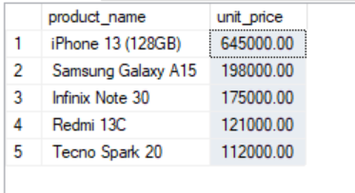
-- A2: Customers based in Lagos State
SELECT
CONCAT(first_name, ' ', last_name) AS full_name,
city,
signup_date
FROM customers
WHERE state = 'Lagos'
ORDER BY signup_date;
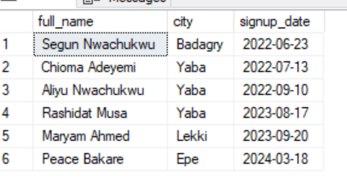
-- A3: Ten most recently placed orders
SELECT TOP (10)
order_id,
order_date,
status
FROM orders
ORDER BY order_date DESC, order_id DESC;
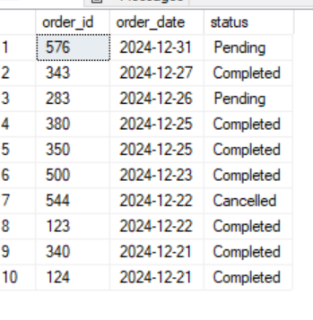
-- A4: Count discontinued products
SELECT
COUNT(*) AS discontinued_products
FROM products
WHERE is_active = 0;
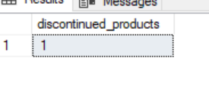
-- A5: Distinct order statuses
SELECT DISTINCT
status
FROM orders
ORDER BY status;

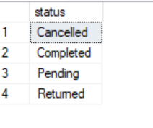
-- B1: Number of orders and total shipping fees by order status
SELECT
status,
COUNT(*) AS order_count,
SUM(shipping_fee) AS total_shipping_fees
FROM orders
GROUP BY status
ORDER BY total_shipping_fees DESC;
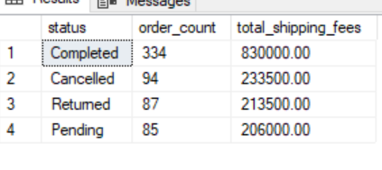
-- B2: Number of products and average unit price by category
SELECT
c.category_name,
COUNT(p.product_id) AS product_count,
CAST(ROUND(AVG(p.unit_price), 0) AS INT) AS average_unit_price
FROM categories AS c
INNER JOIN products AS p
ON c.category_id = p.category_id
GROUP BY c.category_id, c.category_name
ORDER BY average_unit_price DESC;
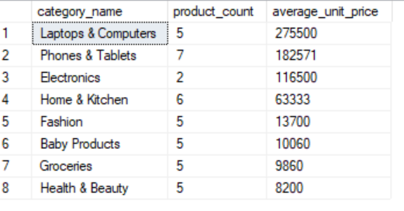
-- B3: Monthly order volume for 2024
SELECT
YEAR(order_date) AS order_year,
MONTH(order_date) AS month_number,
DATENAME(MONTH, order_date) AS month_name,
COUNT(*) AS order_volume
FROM orders
WHERE order_date >= '2024-01-01'
AND order_date < '2025-01-01'
GROUP BY
YEAR(order_date),
MONTH(order_date),
DATENAME(MONTH, order_date)
ORDER BY
order_year,
month_number;
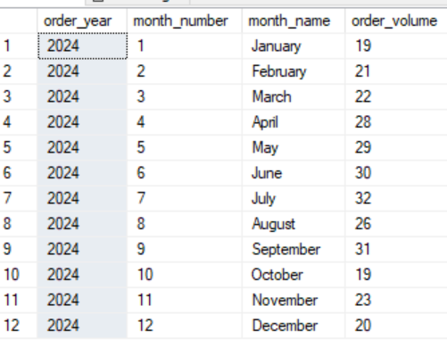
-- B4: Successful payment breakdown by payment method
SELECT
payment_method,
COUNT(*) AS payment_count,
CAST(SUM(amount) AS DECIMAL(18, 2)) AS total_amount_received
FROM payments
WHERE status = 'Successful'
GROUP BY payment_method
ORDER BY total_amount_received DESC;
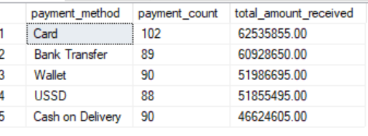
-- B5: Categories containing more than five products
SELECT
c.category_name,
COUNT(p.product_id) AS number_of_products
FROM categories AS c
INNER JOIN products AS p
ON c.category_id = p.category_id
GROUP BY
c.category_id,
c.category_name
HAVING COUNT(p.product_id) > 5
ORDER BY
number_of_products DESC;

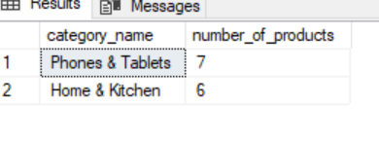
-- C1: Top 10 products by total revenue from completed orders
SELECT TOP (10)
p.product_name,
CAST(
SUM(
oi.quantity
* oi.unit_price
* (1 - oi.discount)
) AS DECIMAL(18, 2)
) AS total_revenue
FROM products AS p
INNER JOIN order_items AS oi
ON p.product_id = oi.product_id
INNER JOIN orders AS o
ON oi.order_id = o.order_id
WHERE o.status = 'Completed'
GROUP BY
p.product_id,
p.product_name
ORDER BY
total_revenue DESC;
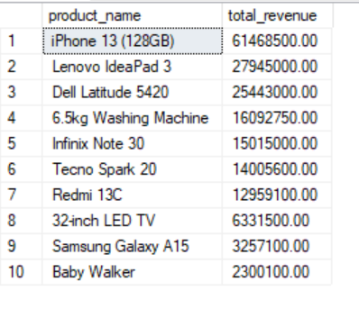
-- C2: Completed orders and total spending by customer
SELECT
c.customer_id,
CONCAT(c.first_name, ' ', c.last_name) AS full_name,
COUNT(DISTINCT o.order_id) AS completed_orders,
CAST(
COALESCE(
SUM(
oi.quantity
* oi.unit_price
* (1 - oi.discount)
),
0
) AS DECIMAL(18, 2)
) AS total_amount_spent
FROM customers AS c
LEFT JOIN orders AS o
ON c.customer_id = o.customer_id
AND o.status = 'Completed'
LEFT JOIN order_items AS oi
ON o.order_id = oi.order_id
GROUP BY
c.customer_id,
c.first_name,
c.last_name
ORDER BY
total_amount_spent DESC;
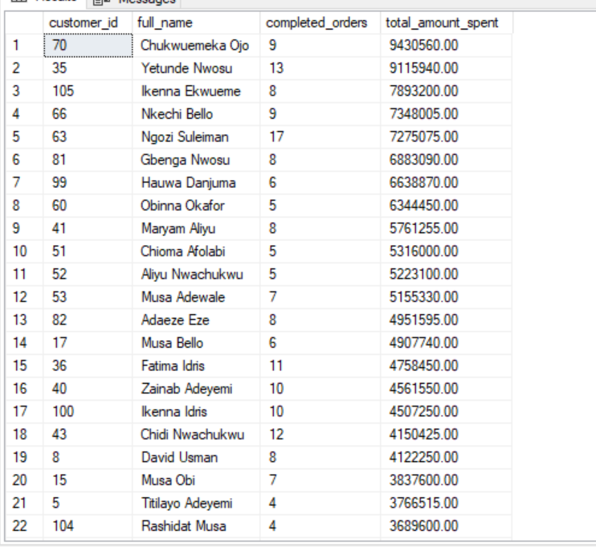
-- C3: Sales representatives and their managers
SELECT
CONCAT(rep.first_name, ' ', rep.last_name) AS sales_representative_name,
rep.job_title,
CONCAT(manager.first_name, ' ', manager.last_name) AS manager_name
FROM employees AS rep
LEFT JOIN employees AS manager
ON rep.manager_id = manager.employee_id
WHERE rep.job_title LIKE '%Sales%'
ORDER BY
sales_representative_name;
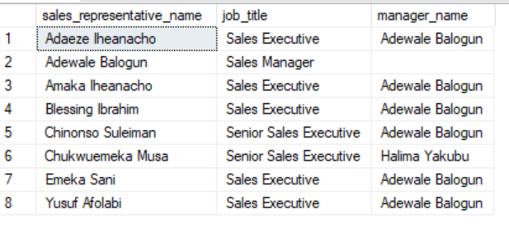
-- C4: Total completed-order revenue for each customer state
SELECT
c.state,
SUM(oi.quantity * oi.unit_price * (1 - oi.discount)) AS total_revenue
FROM customers AS c
INNER JOIN orders AS o
ON c.customer_id = o.customer_id
INNER JOIN order_items AS oi
ON o.order_id = oi.order_id
WHERE o.status = 'Completed'
GROUP BY c.state
ORDER BY total_revenue DESC;
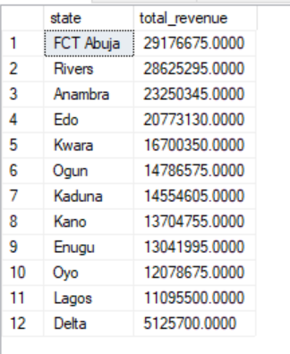
-- C5: Products that have never appeared in any order

SELECT
p.product_id,
p.product_name
FROM products AS p
LEFT JOIN order_items AS oi
ON p.product_id = oi.product_id
WHERE oi.product_id IS NULL
ORDER BY p.product_id;
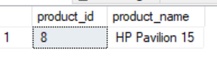
-- D1: Customers whose completed spend is above the average customer spend
SELECT
CONCAT(c.first_name, ' ', c.last_name) AS customer_name,
SUM(oi.quantity * oi.unit_price * (1 - oi.discount)) AS total_spend
FROM customers AS c
INNER JOIN orders AS o
ON c.customer_id = o.customer_id
INNER JOIN order_items AS oi
ON o.order_id = oi.order_id
WHERE o.status = 'Completed'
GROUP BY c.customer_id, c.first_name, c.last_name
HAVING SUM(oi.quantity * oi.unit_price * (1 - oi.discount)) >
(
SELECT AVG(customer_total)
FROM
(
SELECT
o2.customer_id,
SUM(oi2.quantity * oi2.unit_price * (1 - oi2.discount)) AS customer_total
FROM orders AS o2
INNER JOIN order_items AS oi2
ON o2.order_id = oi2.order_id
WHERE o2.status = 'Completed'
GROUP BY o2.customer_id
) AS customer_spend
)
ORDER BY total_spend DESC;
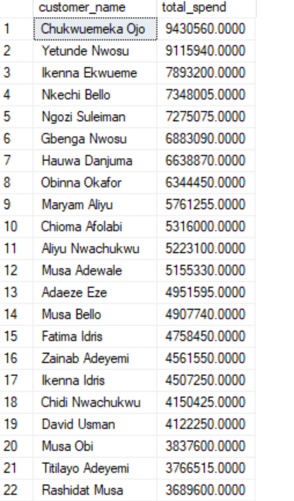
-- D2: Highest-value completed order
SELECT TOP (1)
o.order_id,
CONCAT(c.first_name, ' ', c.last_name) AS customer_name,
SUM(oi.quantity * oi.unit_price * (1 - oi.discount)) AS total_order_value
FROM orders AS o
INNER JOIN customers AS c
ON o.customer_id = c.customer_id
INNER JOIN order_items AS oi
ON o.order_id = oi.order_id
WHERE o.status = 'Completed'
GROUP BY
o.order_id,
c.first_name,
c.last_name
ORDER BY total_order_value DESC;
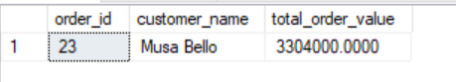
-- D3: Categories with gross profit above the average category profit

WITH category_profit AS
(
SELECT
c.category_id,
c.category_name,
SUM(
oi.quantity *
(
oi.unit_price * (1 - oi.discount)
- p.cost_price
)
) AS gross_profit
FROM categories AS c
INNER JOIN products AS p
ON c.category_id = p.category_id
INNER JOIN order_items AS oi
ON p.product_id = oi.product_id
INNER JOIN orders AS o
ON oi.order_id = o.order_id
WHERE o.status = 'Completed'
GROUP BY
c.category_id,
c.category_name
)
SELECT
category_name,
gross_profit
FROM category_profit
WHERE gross_profit >
(
SELECT AVG(gross_profit)
FROM category_profit
)
ORDER BY gross_profit DESC;
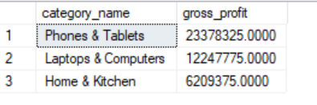
-- D4: Products priced above the average unit price of their own category

SELECT
p.product_name,
p.unit_price,
c.category_name
FROM products AS p
INNER JOIN categories AS c
ON p.category_id = c.category_id
WHERE p.unit_price > (
SELECT AVG(p2.unit_price)
FROM products AS p2
WHERE p2.category_id = p.category_id
)
ORDER BY
c.category_name,
p.unit_price DESC;
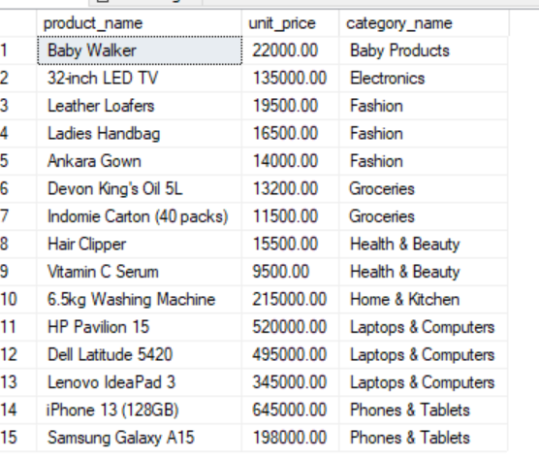
-- E1: Rank sales representatives by total completed sales

;WITH rep_sales AS (
SELECT
e.employee_id,
CONCAT(e.first_name, ' ', e.last_name) AS rep_name,
COALESCE(
SUM(
oi.quantity
* oi.unit_price
* (1 - oi.discount)
),
0
) AS total_sales
FROM employees AS e
LEFT JOIN orders AS o
ON e.employee_id = o.employee_id
AND o.status = 'Completed'
LEFT JOIN order_items AS oi
ON o.order_id = oi.order_id
WHERE e.job_title LIKE '%Sales%'
GROUP BY
e.employee_id,
e.first_name,
e.last_name
)
SELECT
rep_name,
CAST(total_sales AS DECIMAL(18, 2)) AS total_sales,
RANK() OVER (
ORDER BY total_sales DESC
) AS sales_rank
FROM rep_sales
ORDER BY
sales_rank,
rep_name;
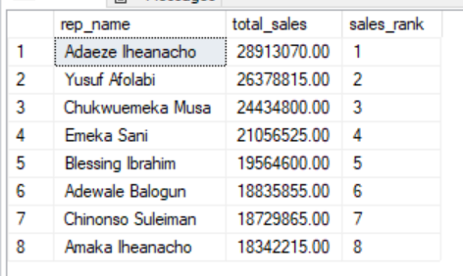
-- E2: Cumulative monthly revenue across 2023 and 2024

;WITH monthly_revenue AS (
SELECT
DATEFROMPARTS(
YEAR(o.order_date),
MONTH(o.order_date),
1
) AS order_month,
SUM(
oi.quantity
* oi.unit_price
* (1 - oi.discount)
) AS monthly_revenue
FROM orders AS o
INNER JOIN order_items AS oi
ON o.order_id = oi.order_id
WHERE o.status = 'Completed'
AND o.order_date >= '2023-01-01'
AND o.order_date < '2025-01-01'
GROUP BY
YEAR(o.order_date),
MONTH(o.order_date)
)
SELECT
order_month,
CAST(monthly_revenue AS DECIMAL(18, 2)) AS monthly_revenue,
CAST(
SUM(monthly_revenue) OVER (
ORDER BY order_month
ROWS BETWEEN UNBOUNDED PRECEDING AND CURRENT ROW
) AS DECIMAL(18, 2)
) AS cumulative_revenue
FROM monthly_revenue
ORDER BY
order_month;
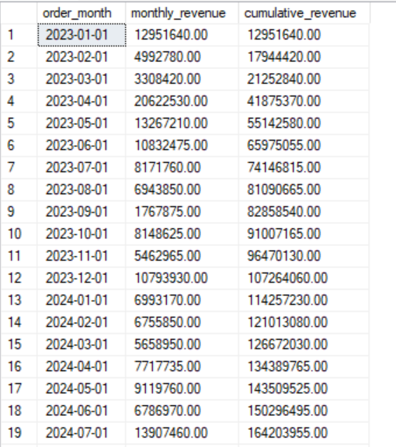
-- E3: Top-selling product by revenue in each category

;WITH product_revenue AS (
SELECT
c.category_id,
c.category_name,
p.product_id,
p.product_name,
SUM(
oi.quantity
* oi.unit_price
* (1 - oi.discount)
) AS total_revenue
FROM categories AS c
INNER JOIN products AS p
ON c.category_id = p.category_id
INNER JOIN order_items AS oi
ON p.product_id = oi.product_id
INNER JOIN orders AS o
ON oi.order_id = o.order_id
WHERE o.status = 'Completed'
GROUP BY
c.category_id,
c.category_name,
p.product_id,
p.product_name
),
ranked_products AS (
SELECT
category_name,
product_name,
total_revenue,
ROW_NUMBER() OVER (
PARTITION BY category_name
ORDER BY total_revenue DESC, product_name
) AS product_rank
FROM product_revenue
)
SELECT
category_name,
product_name,
CAST(total_revenue AS DECIMAL(18, 2)) AS total_revenue
FROM ranked_products
WHERE product_rank = 1
ORDER BY
category_name;
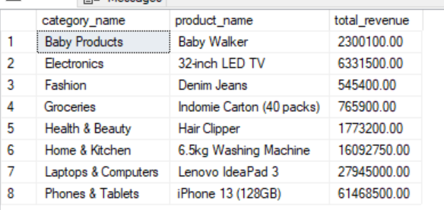
-- E4: Month-over-month completed revenue growth

;WITH monthly_revenue AS (
SELECT
DATEFROMPARTS(
YEAR(o.order_date),
MONTH(o.order_date),
1
) AS order_month,
SUM(
oi.quantity
* oi.unit_price
* (1 - oi.discount)
) AS monthly_revenue
FROM orders AS o
INNER JOIN order_items AS oi
ON o.order_id = oi.order_id
WHERE o.status = 'Completed'
AND o.order_date >= '2023-01-01'
AND o.order_date < '2025-01-01'
GROUP BY
YEAR(o.order_date),
MONTH(o.order_date)
),
revenue_comparison AS (
SELECT
order_month,
monthly_revenue,
LAG(monthly_revenue, 1) OVER (
ORDER BY order_month
) AS previous_month_revenue
FROM monthly_revenue
)
SELECT
order_month,
CAST(monthly_revenue AS DECIMAL(18, 2)) AS monthly_revenue,
CAST(previous_month_revenue AS DECIMAL(18, 2))
AS previous_month_revenue,
CAST(
CASE
WHEN previous_month_revenue IS NULL
OR previous_month_revenue = 0
THEN NULL
ELSE
(
(monthly_revenue - previous_month_revenue)
/ previous_month_revenue
) * 100
END AS DECIMAL(18, 2)
) AS mom_growth_percentage
FROM revenue_comparison
ORDER BY
order_month;
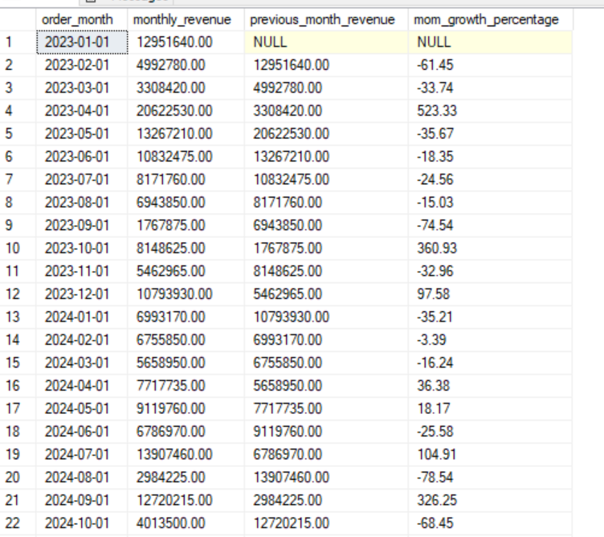
-- E5: Customer spending compared with the average spend in their segment

;WITH customer_spend AS (
SELECT
c.customer_id,
CONCAT(c.first_name, ' ', c.last_name) AS customer_name,
c.segment,
COALESCE(
SUM(
oi.quantity
* oi.unit_price
* (1 - oi.discount)
),
0
) AS total_spend
FROM customers AS c
LEFT JOIN orders AS o
ON c.customer_id = o.customer_id
AND o.status = 'Completed'
LEFT JOIN order_items AS oi
ON o.order_id = oi.order_id
GROUP BY
c.customer_id,
c.first_name,
c.last_name,
c.segment
)
SELECT
customer_name,
segment,
CAST(total_spend AS DECIMAL(18, 2)) AS total_spend,
CAST(
AVG(total_spend) OVER (
PARTITION BY segment
) AS DECIMAL(18, 2)
) AS segment_average_spend,
CAST(
total_spend
- AVG(total_spend) OVER (
PARTITION BY segment
) AS DECIMAL(18, 2)
) AS difference_from_segment_average
FROM customer_spend
ORDER BY
segment,
total_spend DESC;
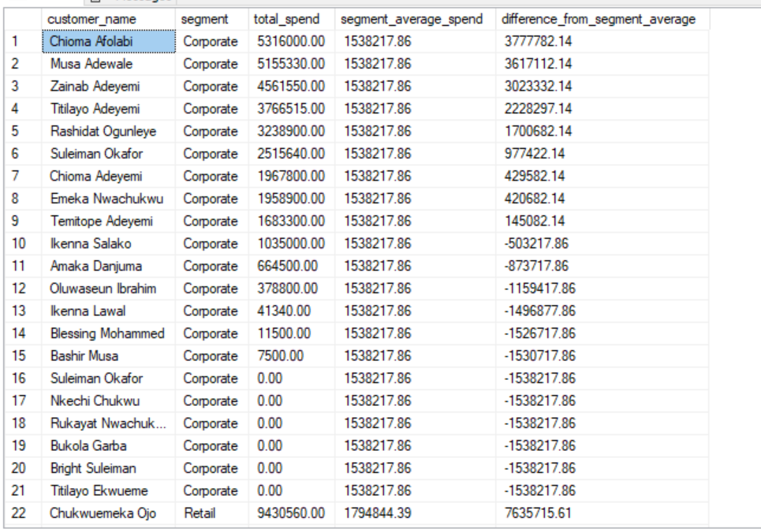

BUSINESS INSIGHT REPORT
Summary
This report analyses NaijaMart’s completed orders, products, customers, payment methods, sales representatives, and monthly revenue trends from 2023 to 2024. Cancelled, pending, and returned orders were excluded from realised sales calculations.
- The leading product by completed-order revenue was iPhone 13 (128GB), generating ₦61,468,500. The strongest product category was Baby Products, whose leading product generated ₦2,300,100. This indicates that management should protect availability of high-performing products and monitor their stock levels.

- The highest-value customer was Chukuemeka Ojo, with completed spending of ₦9,430,560 across 9 completed orders. Customers above the overall average spend should be targeted with loyalty benefits, personalized offers, and early access to new products.

- FCT Abuja generated the highest completed-order revenue at ₦29,176,675, while Delta generated lowest with ₦5,125,700. Revenue concentration in the leading state may represent a strong market opportunity, but it may also expose NaijaMart to regional risk if the business depends too heavily on one location.

- Adaeze Iheanacho3 ranked first in completed sales with ₦28,913,070. The difference between the highest- and lowest-ranked representatives was ₦10,570,855. Management should investigate whether this difference reflects territory allocation, customer portfolios, experience, or sales activity.

- Completed-order revenue fluctuated substantially during the 2023–2024 period. Revenue increased by 523.33% in April 2023, rising from ₦3,308,420 in March 2023 to ₦20,622,530 in April 2023. The largest decline occurred in August 2024, when revenue fell by 78.54%, from ₦13,907,460 in July 2024 to ₦2,984,225. These sharp changes may reflect seasonal demand, promotions, stock availability, or the exclusion of cancelled, pending, and returned orders from realized revenue.

- The payment method with the highest successful payment value was Card, with ₦62,535,855 received. In addition, 8 products never appeared in the order_items table. These products may require repricing, better promotion, improved product descriptions, or discontinuation.

Conclusion
Overall, the analysis shows that NaijaMart should focus on its strongest products, highest-value customers, leading regions, and most effective sales representatives. However, all revenue conclusions are based on completed orders only; cancelled, pending, and returned orders were excluded. Therefore, the findings describe realized sales rather than total order activity.
Recommendations
- Improve inventory planning: Maintain sufficient stock for the top-revenue products and categories identified in C1 and E3.
- Target valuable customers: Create loyalty campaigns for customers whose spend exceeds their segment average, while using targeted promotions to reactivate low-spending customers.
- Strengthen regional and sales-representative strategies: Investigate the highest-performing states and representatives, then replicate successful practices in weaker regions or teams.
- Review payment performance: Promote reliable and popular payment methods while investigating pending-payment patterns.
- Review unsold products: Reprice, promote, bundle, or discontinue products identified by C5 as never appearing in an order.

